POWER BI WEEK 2 PROJECT REPORT

Superstore Sales Dashboard – Data Visualization and Analysis

Name: Keerthana R
Roll No.: E25DA024
Department: B.Sc. DS and AI
Tool Used: Microsoft Power BI
Dataset: Sample Superstore Sales Data

1. Introduction

In Week 2, the cleaned Superstore dataset was used to create an interactive dashboard in Microsoft Power BI. Different visualizations and cards were created to understand sales, profit, discount, category performance, and the relationship between sales and discount.

2. Objective

The main objective of this project is to represent the Superstore data visually using suitable Power BI charts and cards. The dashboard helps to understand important business metrics and compare different categories.

3. Dashboard Visualizations

3.1 Total Sales Card

A Card visual was created using the Sales field to display the total sales value. This provides a quick summary of the overall sales performance.
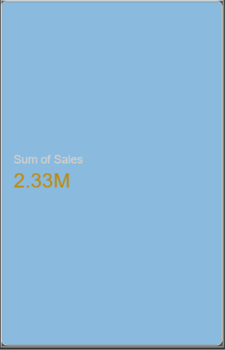

3.2 Total Profit Card

A Card visual was created using the Profit field. It provides a quick view of the total profit generated from the sales data.
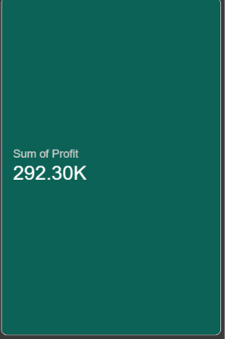

3.3 Discount Card

A Card visual was created using the Discount field to provide a summary of the discount information in the dataset.
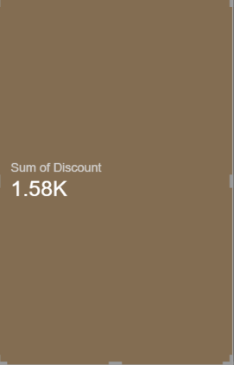

3.4 Sales by Category

A chart was created using Category and Sales.

- Category – Axis
- Sales – Values

This visualization helps compare sales across different product categories.
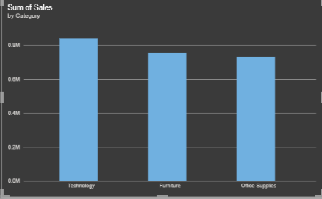

3.5 Sales by Region

A bar chart was created using Region and Sales.

- Region – Axis
- Sales – Values

This allows regional sales performance to be compared visually.
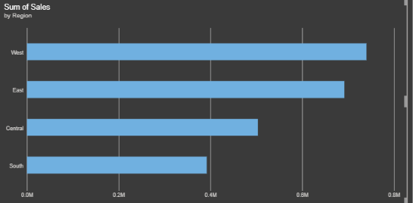

3.6 Sales by Sub-Category and Month

A visualization was created using:

- Order Date – Month Copy 3 – Axis
- Sales – Values
- Sub-Category – Legend

This visualization shows how sales vary across months for different sub-categories.
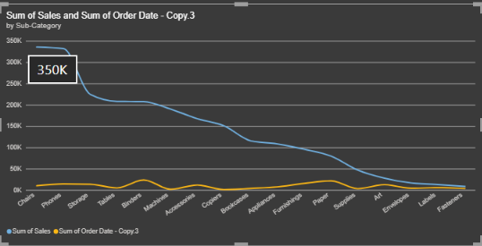

3.7 Waterfall Chart – Profit

A Waterfall chart was created using profit-related data to show how different categories or components contribute to the overall profit.

This visualization helps understand increases and decreases in profit.

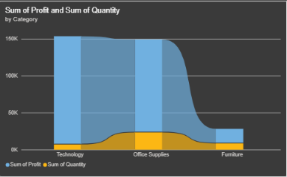

3.8 Scatter Chart – Sales and Discount

A Scatter chart was created to examine the relationship between Sales and Discount.

- Sales – Value
- Discount – Value

The scatter chart helps identify the distribution and relationship between sales values and discount levels.
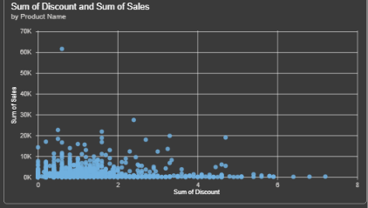

3.5 Sales by Segment – Donut Chart
Legend: Segment
Values: Sales
This visualization shows the contribution of each customer segment to total sales.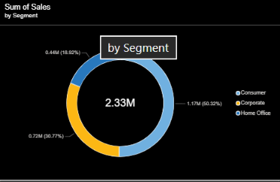

4. Dashboard Design

Different visual elements such as Cards, Bar Charts, Line Charts, Waterfall Charts, and Scatter Charts were arranged on the Power BI report page. Formatting options were also used to improve the appearance and readability of the dashboard.

5. Key Analysis

The dashboard provides a visual summary of important Superstore business metrics. Sales can be compared across categories and regions, monthly sales can be viewed by sub-category, and profit can be examined using a Waterfall chart. The Scatter chart provides a way to explore the relationship between sales and discount.

6. Result

The Superstore dataset was successfully converted into a visual Power BI dashboard using multiple visualization types. The dashboard provides an easy way to explore sales, profit, discount, category, region, and sub-category information.

7. Conclusion

Week 2 provided practical experience in creating dashboards and visualizations using Microsoft Power BI. Cards were used for key metrics, while different charts were used to compare categories, analyze monthly sales, understand profit changes, and explore the relationship between sales and discount. The completed dashboard makes the cleaned Superstore data easier to understand and analyze.

